**!!!Grade 6: English lockdown lessons!!!**

***11 May- 15 May 2020***

***Lesson plan:*** Subject, verb and object. Poetry, reading and writing

***Lesson outcome:*** Learner should understand the difference between subject, verb and object. They should answer questions about it. Learner should practice the reading passage. Learners must choose a poem and prepare it for class.

***Time allocation:*** Depends on the external factors. Learner is in charge of own time allocation and chooses their own framework and days of completion during the week. Everything should be up to date by Friday, 15 May 2020

YouTube link: https://www.youtube.com/watch?v=5MT4ApF466Y

Helooooooo Grade 6 learners! Yet, another week full of new things and exciting stuff! I have attached the memorandum of last week’s questions. I hope and I trust that the figures of speech are drilled into your brains and never to be forgotten! Hehe. We will definitely recap on all the figures of speech once we return to school.

I have attached the week’s work and you are once again responsible to divide your work into sections for each day. I know some days are difficult and there isn’t always time. But I am asking you very nicely to make time!! Remember, this is work that was supposed to be done in class- so every little thing that we discuss in the powerpoints, notes etc is important! This week’s themes are subject, verb, object and some study work! I will add a few poems, a reading passage and a written assignment that you should practice.

I miss you guys so much and I know that you are giving your very best at home! Please thank your parents for everything that they are doing for you! Appreciate them and love them for all their hard work. Keep it up! I believe in you!

Kind regards,

Ms. Zarese

­­­­­­­­­­­­­­­________________________________________________________________

**Memorandum of last weeks work (4 May-8 May 2020)**

**Question 1:**

1. Smart as a fox (boy)
2. Quick as a cat (flyhalf)
3. Tough as nails (dad)
4. Hard as rock (cement)
5. Tough as a tiger (player)
6. Cried like a baby (boy)
7. Drinks like a fish (brother)
8. Slithered like a snake (she)
9. Thin as a rail (friend)
10. Fights like a lion (man)
11. Ran like the wind (boy)

**Question 2:**

1. Metaphor
2. Metaphor
3. Metaphor
4. Simile
5. Simile

**Question3:**

1. Non-living: wind

Living: sang

1. Non-living: microwave timer

Living: told

1. Non-living: rocks

Living: danced

1. Non-living: rain

Living: kissed

1. Non-living: sunflowers

Living: nodded

1. Non-living: snow

Living: whispered

**Question 4:**

Own opinion and examples

**Question 5:**

1) Emily Esterhuizen enters the entry level parking lot

2) Andy Anderson attracts nice and attractive people.

3) Only oranges and olives are ordered from the store.

**Question 6:**

Own examples. Make sure that you used the example words.

**Question 7:** Here are a few examples-

1. Sun: hot? burn? large?
2. School: far? difficult? boring?
3. Car: fast? pretty? expensive?
4. Cheetah: fast? wild?

**Question 8:**

|  |  |
| --- | --- |
| Idiom: | Meaning: |
| A blessing in disguise. | Risky |
| Better late than never. | If something is fun, you don’t look at the clock. |
| Go back to the drawing board | Making people feel comfortable. |
| It’s not rocket science. | Rather be late than not pitching at all. |
| Time flies when you’re having fun. | Not complicated |
| Break the ice. | Starting from the beginning. |
| Don’t put all your eggs in one basket. | It ***might*** be bad….. |

**Question 9:**

There must be an example AND a picture to explain the figure of speech.

**Question 10:**

1. My life is a dream= metaphor
2. (dream)Like a tiger waking= simile
3. The trees are purple= metaphor
4. The stars talk away the night= personification
5. The moaning moon= personification

**“MINI TEST”**

1. Hyperbole
2. Personification
3. Alliteration
4. Simile
5. Idiom
6. Onomatopoeia
7. Assonance
8. Metaphor

Section B:

1. Simile
2. Onomatopoeia
3. Personification
4. Alliteration
5. Hyperbole
6. Metaphor
7. Idiom
8. Assonance

Section C:

1. Simile
2. Personification
3. Simile
4. Personification
5. Metaphor
6. Personification
7. Personification
8. Personification

________________________________________________

*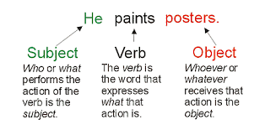!!!Subject, Verb, Object!!!*

|  |  |  |
| --- | --- | --- |
| SUBJECT: | VERB: | OBJECT: |
| WHO WE ARE TALKING ABOUT IN THE SENTENCE. (“WIE IS DIE PERSOON OF ONDERWERP”) | THE DOING WORD OF THE SENTENCE. WHAT IS THE SUBJECT DOING??? (“WAT WORD GEDOEN”) | THIS IS THE THING THE VERB IS WORKING ON. (“WAT IS DIE VOORWERP”) |
| “WIE” | “DOEN” | “WAT” |

Question 1: Write the subject, verb and object of the following sentences:

1. The police officers borrow money.

Subject:___________

Verb:_____________

Object:____________

1. The learners broke a window.

Subject:___________

Verb:_____________

Object:____________

1. Cats eat fish.

Subject:___________

Verb:_____________

Object:____________

1. The chef fries an egg.

Subject:___________

Verb:_____________

Object:____________

1. The doctor helps the patient.

Subject:___________

Verb:_____________

Object:____________

1. I painted the door blue.

Subject:___________

Verb:_____________

Object:____________

1. She bought a new shirt.

Subject:___________

Verb:_____________

Object:____________

1. He plays the piano beautifully.

Subject:___________

Verb:_____________

Object:____________

1. People lie on the beach.

Subject:___________

Verb:_____________

Object:____________

1. Toddlers eat their crayons.

Subject:___________

Verb:_____________

Object:____________

**Question 2: Practice the following reading passage. During the first week back at school, we will assess your reading skills. This will be part of the formal assessments. Good luck.**

**Part of the Family**

We were all so excited to learn that Mom was going to let us adopt and add a new member to our family! My brother, my two sisters, and I had worked for weeks to convince Mom that we were responsible enough to have a new puppy. Many days after school I had visited the library and researched puppy training, the proper feeding of a puppy, how to socialize a new puppy, and even the meanings of names one might choose for a puppy. All of us had selected certain jobs that would need to be performed if we were lucky enough to convince Mom to get a puppy. In order to prove to Mom that she would not be the only person taking care of our new family member, we had divided the jobs among us and created a chart for the first month.

Finally, Mom gave in and agreed to let us adopt a puppy! Now the real work would begin. We decided to visit the SPCA in order to select just the right puppy to join our family. Of course, once we saw all the puppies and dogs available, none of us could decide on only one. Each little face had its own special charm. Who could resist those big brown eyes? All the puppies were so thrilled we were visiting them, but each was unaware that just one would be leaving with us. They jumped, they wagged their tails as if each had a motor attached. They joyfully licked every bare inch of skin we had. How would we ever decide?

As we strolled through the aisles of kennels, I noticed one little bundle of fur. He sat off to the side of the temporary home he shared with three other puppies. He quietly watched as

his unruly housemates tried to be the most outgoing, the cutest, and the perfect pet for us by showing their enthusiasm. As I walked closer to his corner, he peered at me and smiled a crooked puppy grin. His tail wagged his entire body. He jumped up to greet me with a playful lap of his tongue and I noticed his lopsided ears. One ear stood up just a little straighter than the other, giving the impression he was listening quite closely to the words I was saying.

“Hi there, little buddy. What do you think?”. He seemed to know it didn’t matter that he was the smallest and the most **reserved** of the group of puppies occupying the kennel. I motioned for my siblings to join me at the corner and introduced them to “Buddy.”

“This is him, this is Buddy! He needs us, I can tell,” I explained to my brother and sisters.

“I don’t know, he is so tiny and kind of funny looking,” my youngest sister observed.

“He has character,” I explained, feeling rather **defensive** of Buddy. He was not funny looking, he was unique! “Look in his eyes. He knows what you are saying and his feelings are hurt!”

My sister looked at the little bundle of fur with the big eyes and the uneven ears. She reached out her hand, and Buddy gave her a lick. “I’m sorry, Buddy, I didn’t mean to hurt your feelings,” she said.

She looked as if she might cry. “You’re right! Buddy has character.”

Mom joined our little group and introduced herself to our new friend. “Okay, Buddy, I guess you’re it! Do you want to come home with us?” As I watched the little dog’s reaction to her words, I could tell he understood. He tilted his head to one side and flashed us his crooked puppy smile as if to say he knew he was part of the family.

Question 3: I have attached 5 different poems. You can choose any one and practice it on a regular basis. Imagine that it is Eisteddfod!!! You have the chance to impress your audience, teacher and yourself! Your mother/father can coach you and help you. During next week’s lesson we will discuss every poem in detail and answer questions about each poem. Your job for this week is to choose one poem and recite it. Remember practice makes perfect. This will also be past of a formal assessment (once the school has started).

|  |
| --- |
| **My Friend**  Sometimes I feel all thin inside  Insufficient; small;  I feel when people look at me  They don’t see me at all.  I feel that all my beauty’s lost  On cold, indifferent eyes  And offering what I want to give  Would only be unwise.  But then a friend will greet me  and my inner life will bloom  It only takes but one kind word  To sweep away the gloom! |

|  |
| --- |
| **Mr. Nobody**  **I know a funny little man,**  **As quiet as a mouse,**  **Who does the mischief that is done?**  **In everybody's house!**  **There's no one ever sees his face,**  **And yet we all agree,**  **That every plate we break was cracked.**  **By Mr. Nobody.**  **He puts damp wood upon the fire,**  **That kettle cannot boil;**  **His are the feet that bring in mud,**  **And all the carpets soiled.**  **The papers always are mislaid,**  **Who had them last but he?**  **There's no one tosses them about.**  **But Mr. Nobody.**  **The finger marks upon the door,**  **By none of us are made;**  **We never leave the blinds unclosed,**  **To let the curtains fade.**  **The ink we never spill; the boots**  **thats lying around you see,**  **Are not our boots -- they all belong.**  **To Mr. Nobody.** |

[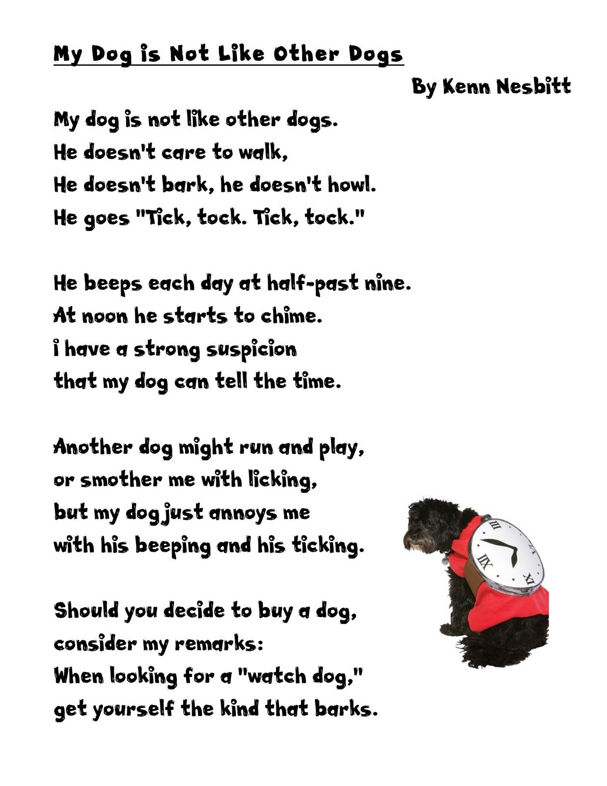](https://www.google.com/url?sa=i&url=https%3A%2F%2Fwww.pinterest.com%2Fpin%2F25121710393944612%2F&psig=AOvVaw0mGSGZ94hr1XQuN-p-ruZt&ust=1588791586689000&source=images&cd=vfe&ved=0CAIQjRxqFwoTCKCPw_yznekCFQAAAAAdAAAAABAe)

[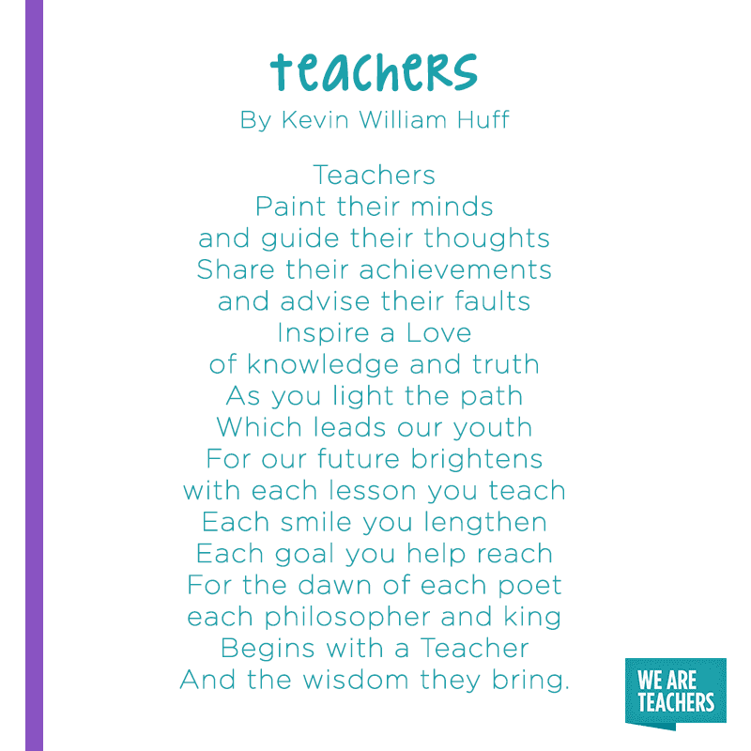](https://www.google.com/url?sa=i&url=https%3A%2F%2Fwww.weareteachers.com%2Fpoems-about-teaching%2F&psig=AOvVaw3B296DyOzk12jFk_We065D&ust=1588793388790000&source=images&cd=vfe&ved=0CAIQjRxqFwoTCJDR5au3nekCFQAAAAAdAAAAABAD)

|  |
| --- |
| **Saw My Teacher on a Saturday**  [**By Emily Mendoza**](https://www.poetrynation.com/members/20618/emily_mendoza)  Saw my teacher on a Saturday, I can't believe it's true. I saw her buying groceries, like normal people do!  She reached for bread and turned around, and then she caught my eye. She gave a smile and said"hello," I thought I would die.  "Oh, hi.hello, Miss Appleton," I mumbled like a fool. I guess I thought that teacher types spend all their time at school.  To make the situation worse, my mom was at my side. So many rows of jars and cans, so little room to hide.  Oh, please, I thought, don't tell my mom what I did yesterday! I closed my eyes and held my breath-hoped she go away. Some people think it's fine to let our teachers walk about. But when it comes to Saturdays, they shouldn't let them out. |

*Question 4: Writing: Describing a (weird/bizarre) picture.*

*Write 5 paragraphs about the picture that I have attached. Yes, it’s a weird picture, but that’s the point! Each paragraph should have a main idea. Remember to start your writing process- you must first do a rough draft (mind map). Please don’t write more than 300 words. Please use descriptive words to explain each paragraph. We will use the planning and the paragraphs in class, so please keep it safe. This will help you and serve as an important resource for a formal assessment. Good luck!*

